Fix, Prevent, Govern: A Field Guide to Data Remediation That Sticks

Executive Summary
Six months ago, a team spent a quarter cleaning up the item master. They deduplicated records, standardized the code values, filled in the missing fields, and closed the project with a green status and a sense of relief. The data was clean. Everyone moved on.
It is not clean anymore. The duplicates are back, because nothing stopped the next person from creating one. The standardized fields have drifted, because entry was still free text. The completeness gains have eroded, because no rule required the fields at the point of entry. The cleanup was real, and it is already undone.
This is the pattern almost every organization repeats: data remediation treated as a project with an end date, when it is actually a discipline with a cadence. The scrub works, briefly, and then the same defects reappear under a new deadline, and the same team is asked to clean the same data again. The cost of poor data quality is well documented,¹ but the quieter cost is the remediation that gets paid for twice, or three times, because it never addressed why the defects appeared in the first place.
This paper lays out the model that breaks the cycle. Every data defect needs three layers of response, not one: Immediate Correction to fix the data now, Prevention to stop the defect from recurring, and a Governance Process to catch it early when it slips through anyway. Fixing without preventing is not remediation. It is polishing a crack that is going to reopen.
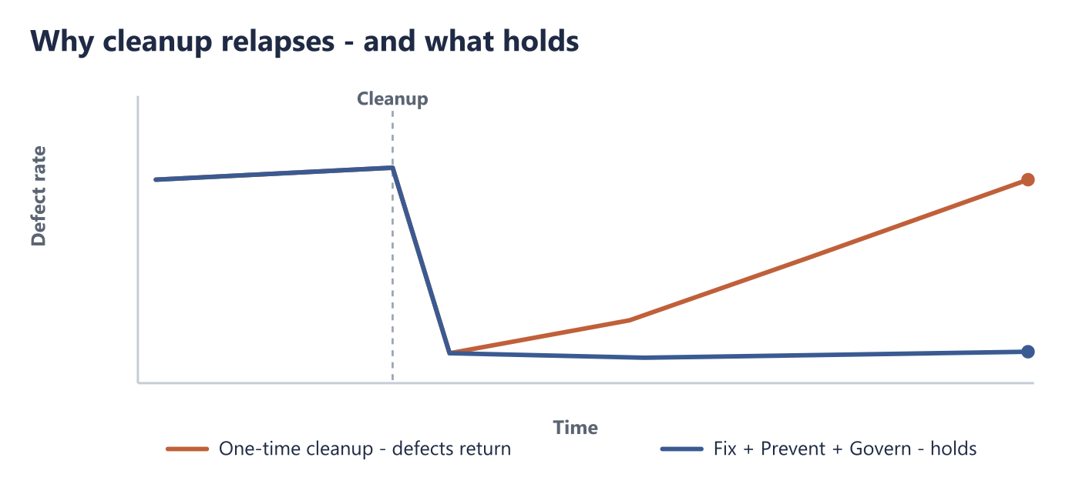

1. Why Data Cleanup Doesn't Stay Clean
The reason cleanup relapses is not carelessness. It is structural. A one-time correction operates on the data that exists today. It does nothing about the mechanism that produced the defective data, so that mechanism keeps producing more. The moment the project closes, the intake that created the mess in the first place is still running, unchanged.
Consider the three most common failure modes. A team deduplicates thousands of records but never adds a uniqueness constraint or an entry-time duplicate check, so new duplicates start accumulating the next day. A team standardizes a coded field to a single approved list but leaves the field as free text, so the variants creep back one keystroke at a time. A team populates every missing mandatory value but never makes the field mandatory in the system, so the next batch of records arrives just as empty.
In each case the correction was competent and the result was temporary, because remediation addressed the symptom and left the cause in place. Data quality is not a state you reach and hold. It is the running balance between the defects your processes introduce and the controls that keep them out.² Cleanup without new controls only resets the balance to zero for a moment. The processes that were producing defects before the cleanup are still producing them after.
That is the first shift in thinking this paper asks for: stop treating remediation as an event, and start treating it as a system with three moving parts.

2. The Map: Six Dimensions of Data Defects
Before you can remediate defects systematically, you have to classify them, because different kinds of defects fail in different ways and demand different fixes. The widely used data-quality dimensions give a practical map.³ A defect that does not fit one of these categories is rare; most real remediation backlogs sort cleanly into six.
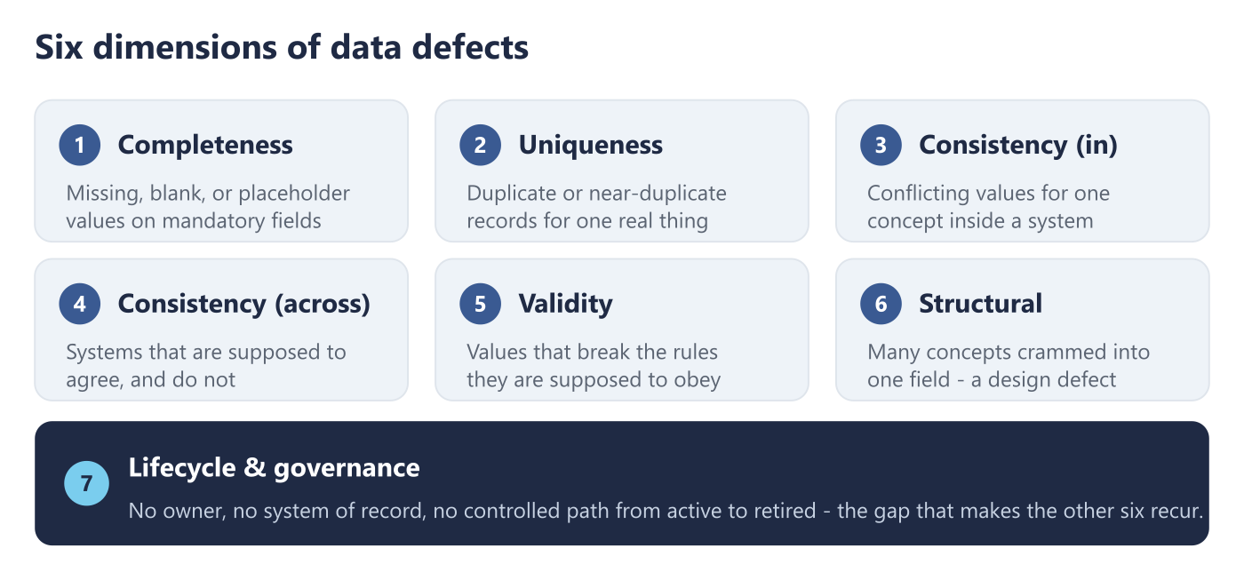
- Completeness. Mandatory values that are missing, blank, or hidden behind placeholders such as "N/A", "NULL", or an empty string that a downstream system reads as real. Completeness defects quietly break every calculation and filter that assumes the field is populated.
- Uniqueness. The same real-world thing represented more than once: exact duplicate keys, or near-duplicates that differ only in spelling, spacing, or case. Uniqueness defects inflate counts, split history, and make a single customer or product look like several.
- Consistency (within a system). The same concept recorded in conflicting ways inside one system: a coded field that holds "EA", "Each", and "ea." for the same unit, or a field mixing codes with free-text descriptions. Consistency defects defeat grouping, sorting, and every report that trusts the values to match.
- Consistency (across systems). The same record disagreeing between two systems that are supposed to agree: different values for the same field, different code schemes, or a record that exists in one system and not the other. Cross-system defects are where a number is correct in each system and wrong the moment you combine them.
- Validity. Values that violate the rules they are supposed to obey: a code that is not on the approved list, an ambiguous code that could mean two things, or an orphaned code no definition covers anymore. Validity defects pass casual inspection and fail the moment someone relies on the code meaning exactly one thing.
- Structural (design). Defects baked into the schema rather than the data: a single field storing several independent concepts at once, or two codes crammed into one column. Structural defects violate the principle that each field should hold one atomic value,⁴ and they cannot be scripted away, they have to be redesigned.
There is a seventh category that behaves less like a defect and more like a gap: lifecycle and governance issues, such as records with no clear owner, no defined system of record, or no controlled path from active to retired. These are not wrong values so much as missing accountability, and they are why the other six recur.
The point of the map is not taxonomy for its own sake. It is that each dimension has a characteristic cause, and therefore a characteristic prevention. You cannot prevent what you have not first named.

3. The Core Move: Fix, Prevent, Govern
Here is the model. For every defect, in every dimension, remediation is not one action but three layers, and a fix is not complete until all three are in place.
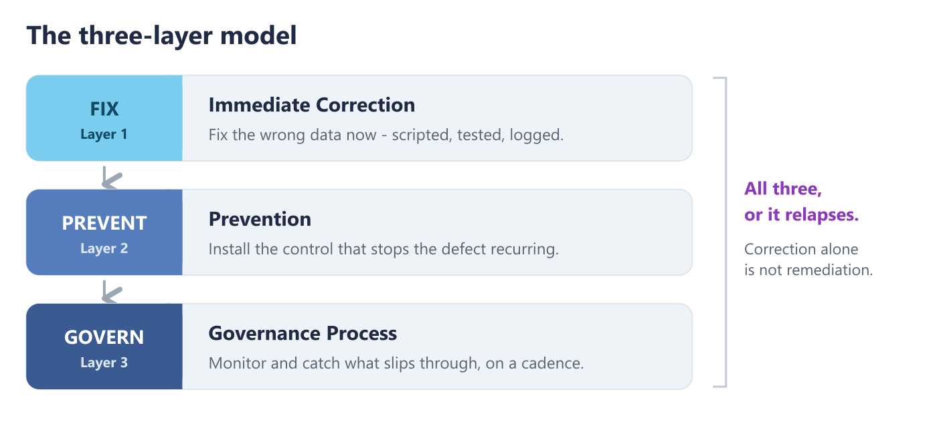
Layer 1 - Immediate Correction. Fix the data that is wrong right now. Profile to find the defects, classify each one, research the correct value from a source of record, and apply the correction through a tested, scripted update with the before and after values logged. This is the layer everyone already does. On its own, it is also the layer that relapses.
Layer 2 - Prevention. Install the control that stops the defect from recurring. This is the layer that most cleanup skips, and the reason cleanup does not last. Prevention is specific to the dimension: a NOT NULL constraint and entry-time validation for completeness; a unique key and a duplicate check at creation for uniqueness; a dropdown backed by an approved list instead of a free-text box for consistency and validity; a schema review gate that rejects a new field storing two concepts for structural defects. Prevention is what converts a correction from a temporary reset into a permanent gain.
Layer 3 - Governance Process. Establish the ongoing monitoring that catches the defect early when it slips past prevention anyway, because some always will. This is a cadence, not a project: a weekly or monthly report of the conformance rate per field, a defined threshold that triggers review when quality drops, and a named person who is accountable for looking at it. Governance is what keeps the balance from silently drifting back to where it started.
Miss any one layer and the model fails in a predictable way. Correction alone relapses. Correction plus prevention holds until the process changes or a new intake path opens, and then drifts unnoticed because no one is watching. Only all three - fix the data, block the cause, and monitor the result - produce remediation that actually stays remediated. The discipline is refusing to mark a defect "done" until every layer is in place.

4. A Worked Example: Remediating Duplicates
The model is easier to trust once you see it run end to end on a single dimension. Take uniqueness, and a backlog of duplicate records sharing the same key.
Immediate Correction. Export the duplicate groups. For each group, choose the surviving record using explicit survivorship rules - the most complete record, or the one from the authoritative system, or the most recently updated, in a defined order.⁵ Merge any values the survivor is missing from the records being retired, repoint every downstream reference to the surviving key, and mark the losers inactive rather than deleting them, so the history is preserved. Record every merge decision and its justification.
Prevention. Add a unique constraint on the key so the database itself refuses a collision. Add a duplicate check at the point of creation that searches for near-matches before a new record is allowed, so the person entering data sees the existing record instead of making a second one. Maintain a synonym list that resolves the common near-duplicate spellings automatically at entry.
Governance Process. Run an automated duplicate scan on a fixed cadence and alert when the count rises above zero. Review the near-duplicate candidates monthly. Set a threshold - any new production duplicate triggers an investigation - and give a named steward the standing responsibility to act on it.
Do only the first step, and the duplicates come back. Do the first two, and they stay away until someone opens a new import path that bypasses the check. Do all three, and the monitor catches that new path the week it appears, before it becomes another cleanup project. That is the difference between remediation that sticks and remediation you will be asked to repeat.

5. Who Owns It: The Owner and Steward Partnership
Three layers only hold if someone is accountable for each of them, which is why the model depends on a clear division of responsibility rather than a general hope that "the data team" will handle it.⁶ Two roles carry it.
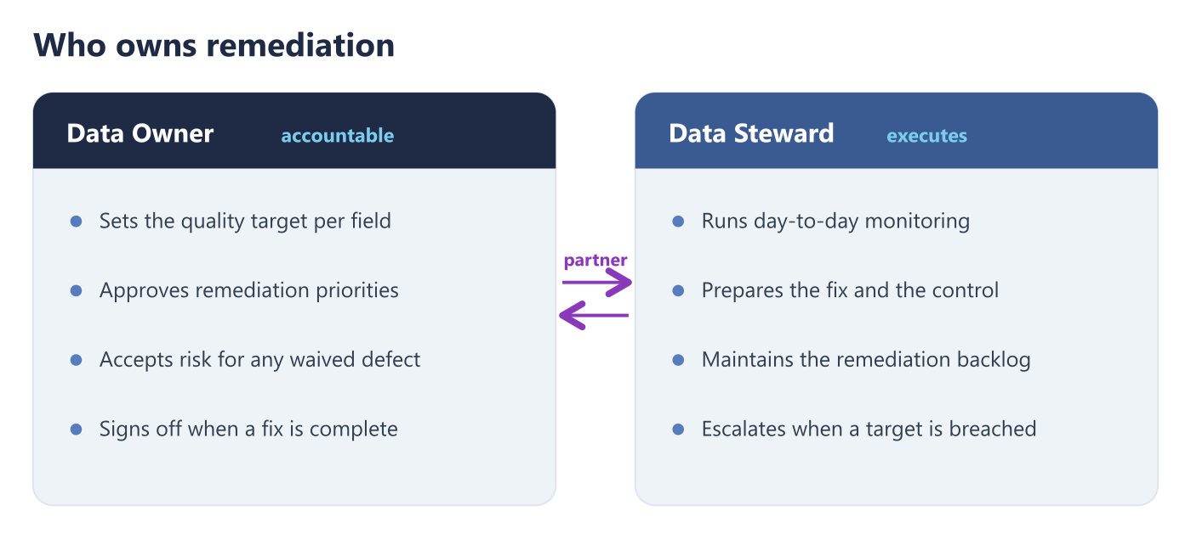
The Data Owner is accountable for the outcome. The owner sets the quality target for each field, approves which defects get remediated first, accepts the documented risk when a defect is knowingly left unaddressed, and signs off when a remediation is complete. The owner is usually a business leader in the domain the data describes, because the definition of "correct" is a business decision, not a technical one.
The Data Steward executes. The steward runs the day-to-day monitoring, identifies new defects, prepares the correction and the preventive rule, maintains the remediation backlog, and escalates to the owner when a target is breached or a decision is needed. The steward is the one who notices the drift before it becomes a project.
The partnership is the point. An owner without a steward sets targets no one monitors. A steward without an owner does careful work that no one with authority will stand behind, which means the exceptions never get decided and the backlog never gets prioritized. Supporting specialists - the engineer who writes the scripts and constraints, the analyst who researches ambiguous values, the administrator who configures the system controls - all work in service of that owner-and-steward spine. Remediation that lacks it produces heroic one-time cleanups and nothing that lasts, because there is no one whose standing job is to keep it clean.

6. Governed Execution: No Cowboy Fixes
How a correction is applied matters as much as whether it is correct, because a remediation done carelessly can do more damage than the defect it fixed. Sustainable remediation runs every correction through the same disciplined path.⁷
Corrections are scripted, never hand-edited in production. A manual edit to a live system is unrepeatable, untestable, and unloggable, and it is the single most common way a remediation turns into an incident. Every correction is written as a script, tested against a development copy, validated in a staging environment where record counts and downstream effects can be confirmed, and only then promoted to production, with a rollback plan ready if it behaves unexpectedly. Structural changes carry an impact assessment first, because splitting or renaming a field touches every report, pipeline, and integration that reads it, and those consumers have to be identified before the change, not surprised by it.
None of this is bureaucracy for its own sake. It is what lets a team remediate at scale without fear, because every change is reversible, every change is logged with its before and after state, and no change reaches production without having been proven safe on a copy first. A team that trusts its own change process remediates faster, not slower, because it is not afraid of what each fix might break.

7. Proving It Stuck: The Metrics That Matter
The whole argument of this paper is that remediation either lasts or it does not, so the metrics that matter are the ones that measure durability, not activity. Counting records corrected tells you how busy the team was. It tells you nothing about whether the defects will be back next quarter.
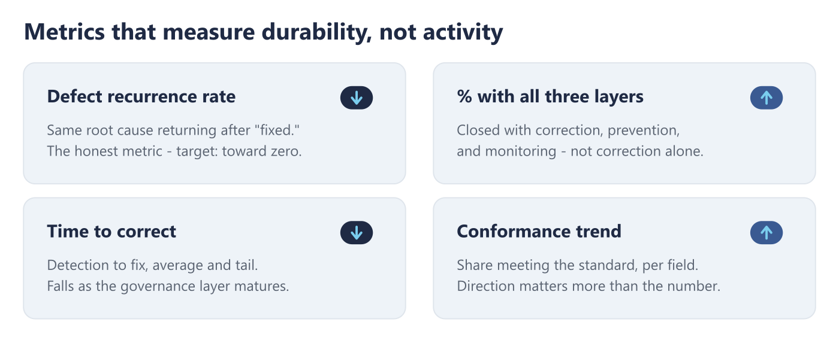
Four measures reveal whether remediation is actually working:
- Defect recurrence rate. How often a defect with the same root cause reappears after it was marked fixed. This is the single most honest metric in remediation. A high recurrence rate is direct evidence that corrections are happening without prevention - that the team is polishing cracks. It should trend toward zero as prevention controls take hold.
- Percentage of remediations with all three layers complete. How many closed items actually have correction, prevention, and monitoring in place, versus how many were closed on the correction alone. This is the leading indicator for next quarter's recurrence rate, and the discipline metric for the model itself.
- Time from detection to correction. How long a known defect sits in the backlog before it is fixed, tracked as an average and at the tail. Remediation that lasts catches defects early and closes them fast, so this number falls as the governance layer matures.
- Conformance trend per dimension. The share of records that meet the standard, per field, tracked over time. The absolute number matters less than the direction: a conformance rate that holds or climbs means the controls are working; one that drifts down means a control has failed or a new intake path has opened, and it is the early warning that turns a future cleanup back into a small fix.
Track these, and remediation stops being a periodic act of faith and becomes a managed, improving system whose health you can actually see.

8. Where to Start
You do not need to remediate all six dimensions at once, and trying to is a common way to stall. Start where the pain is sharpest and the fix is most durable.
Pick the one dimension causing the most visible business harm right now - usually duplicates or a broken coded field that everyone downstream complains about. Remediate it through all three layers, end to end, on that one dimension. Correct the data, install the prevention, stand up the monitor, and name the owner and steward. Doing one dimension completely teaches the pattern and proves the model in a way that doing all six partially never will. Then repeat, dimension by dimension, letting the governance cadence you build for the first one absorb the next.
The organizations that escape the cleanup treadmill are not the ones with the most sophisticated tooling. They are the ones that stopped closing remediation items on the correction alone, and started refusing to call a defect fixed until it also could not come back.

Conclusion
Data cleanup that does not last is not a failure of effort. It is a failure of model - the model that treats remediation as a project to finish rather than a system to run. Every defect needs three layers: fix the data, prevent the cause, and govern the result. Skip prevention and you will pay for the same cleanup again. Skip governance and you will not see the drift until it is a project again. Put all three in place, behind a clear owner and steward and a disciplined change process, and the defects you remove stay removed.
The team that cleaned the item master six months ago did honest work. What they were missing was not skill. It was the second and third layers - and a definition of "done" that included them.
See where your remediation is leaking. Meta4Data's Data Governance Maturity Survey includes a dedicated Data Quality assessment that shows which dimensions are drifting and whether your fixes are built to last.
Working through a live remediation? Contact Meta4Data about a data quality and remediation assessment - built to stand up the prevention and governance layers alongside the cleanup, not after it.

Sources
- See the companion paper, *The Hidden Cost of Bad Data*, for how poor data quality accumulates into an unbudgeted annual cost.
- DAMA International, *DAMA-DMBOK: Data Management Body of Knowledge* - data quality is managed as an ongoing function, not a one-time project.
- DAMA UK Working Group, *The Six Primary Dimensions for Data Quality Assessment* (2013); see also ISO 8000, the international standard for data quality.
- E. F. Codd, *A Relational Model of Data for Large Shared Data Banks*, Communications of the ACM (1970) - the origin of first normal form and the one-value-per-field principle behind structural defects.
- DAMA International, *DAMA-DMBOK* - master data management, golden-record selection, and survivorship rules.
- See the companion paper, *Why Data Governance Programs Fail*, on the accountability gap that leaves remediation unowned.
- Cross-system consistency defects are examined in the companion paper, *Breaking Down the Silos*.

